Project Design Phase-II

Technology Stack (Architecture & Stack)

Date | 31January 3035
Team ID
Project Name | Advancing Nutrition Science through GeminiAI (NutriGen AI)
Maximum Marks | 4Marks

Technical Architecture:

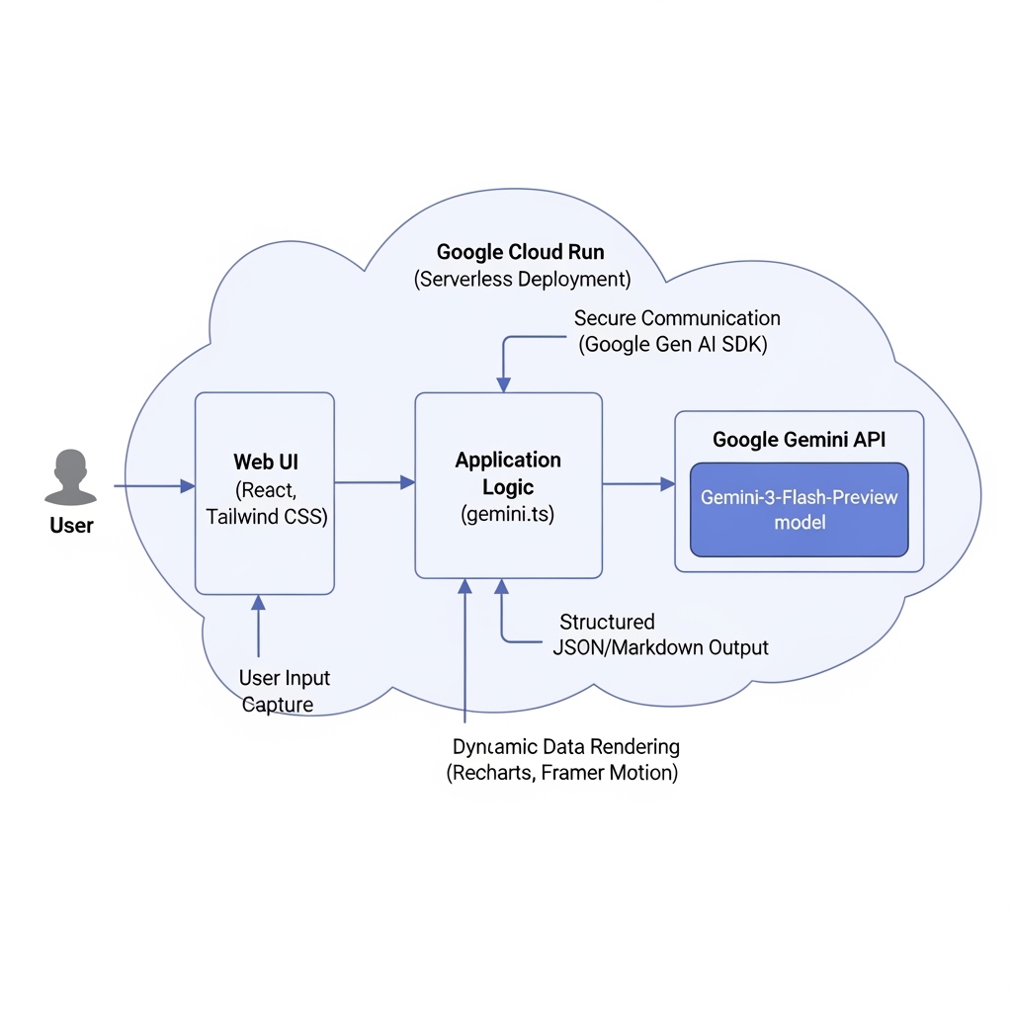
Table-1: Components & Technologies

S.No | Component | Description | Technology
1. | User Interface | How the user interacts with the application (Web UI). Features dynamic sidebars, icons, and charts. | HTML5, Tailwind CSS (v4.1.14), React Js (v19.0.0), Lucide-React (icons), Recharts (Data Visualization), Framer Motion (Animations).
2. | Application Logic-1 | Core frontend state management and component routing. | TypeScript (ES2022), React Hooks (useState, useEffect).
3. | Application Logic-2 | AI Integration Services handling prompts for Nutritional Insights, Meal Planning, and Virtual Coaching. | Google Gen AI SDK (@google/genai v1.29.0).
4. | Application Logic-3 | Application build, bundling, and local development server. | Vite (v6.2.0) with @vitejs/plugin-react.
5. | Database | Local data parsing and relational data mapping (based on dependencies). | SQLite (better-sqlite3 v12.4.1).
6. | Cloud Database | Database Service on Cloud. | N/A for current scope (relies on real-time Generative AI generation).
7. | File Storage | Application configuration and static assets. | Local Filesystem / Cloud Run Ephemeral Storage.
8. | External API-1 | Purpose of External API used for Generative AI content. | Google Gemini API (authenticated via GEMINI_API_KEY).
9. | Machine Learning Model | Purpose of Machine Learning Model: Providing structured nutritional insights, generating 7-day meal plans, and virtual coaching. | Google Gemini (Specifically the gemini-3-flash-preview model).
10. | Infrastructure | Server/Cloud Deployment Environment. | Cloud Server: Google Cloud Run (Application URL injected at runtime).

Table-2: Application Characteristics

S.No | Characteristics | Description | Technology
1. | Open-Source Frameworks | List the open-source frameworks and libraries used to build the application. | React, Vite, Tailwind CSS, Express, TypeScript, Recharts, React-Markdown.
2. | Security Implementations | Access controls implemented, securing API keys from the public frontend. | Environment Variables (.env) for secrets (GEMINI_API_KEY). Hidden from version control via .gitignore.
3. | Scalable Architecture | Justify the scalability of architecture. | Modular Component-Based Architecture (Separation of concerns: NutritionalInsights, MealPlanner, NutritionCoach). Scalable serverless deployments.
4. | Availability | Justify the availability of the application. | Hosted on Google Cloud Run, which automatically scales containerized applications based on traffic.
5. | Performance | Design considerations for the performance of the application. | Vite for optimized, fast Hot Module Replacement (HMR) and bundling. Strict TypeScript compilation (skipLibCheck: true), and lightweight JSON parsing for API responses.

